TASK 2
Excel/Spreadsheet Analysis & Dashboarding
iNeuBytes VIIP — Data Analyst Internship

Intern Name | Devpal Singh Anand
Regd No | INBT019627
Course ID | DAINB20626
Education | BCA · MCA Cyber Security (pursuing)
Dataset | Olist Brazilian E-Commerce (olist.db, SQLite — 96,478 orders)

1. Project Objectives
Clean a raw dataset, aggregate it with pivot tables, compute KPIs with formulas, and build a dashboard that updates when the data changes.
2. Workbook Structure
Sheet | Purpose
README | Cover sheet
Raw Data | 96,478 orders with messiness
Cleaned Data | Cleaned via formulas + 2 derived columns
Data Cleaning Report | Issue/Before/After
Pivot Analysis | 6 pivot tables with conditional formatting
Formulas KPIs | 6 KPI cards + 10 formula demos
Dashboard | KPI strip + 6 charts referencing pivot tables

3. Data Pre-Processing & Cleaning
3.1 Before Cleaning (Raw Data)
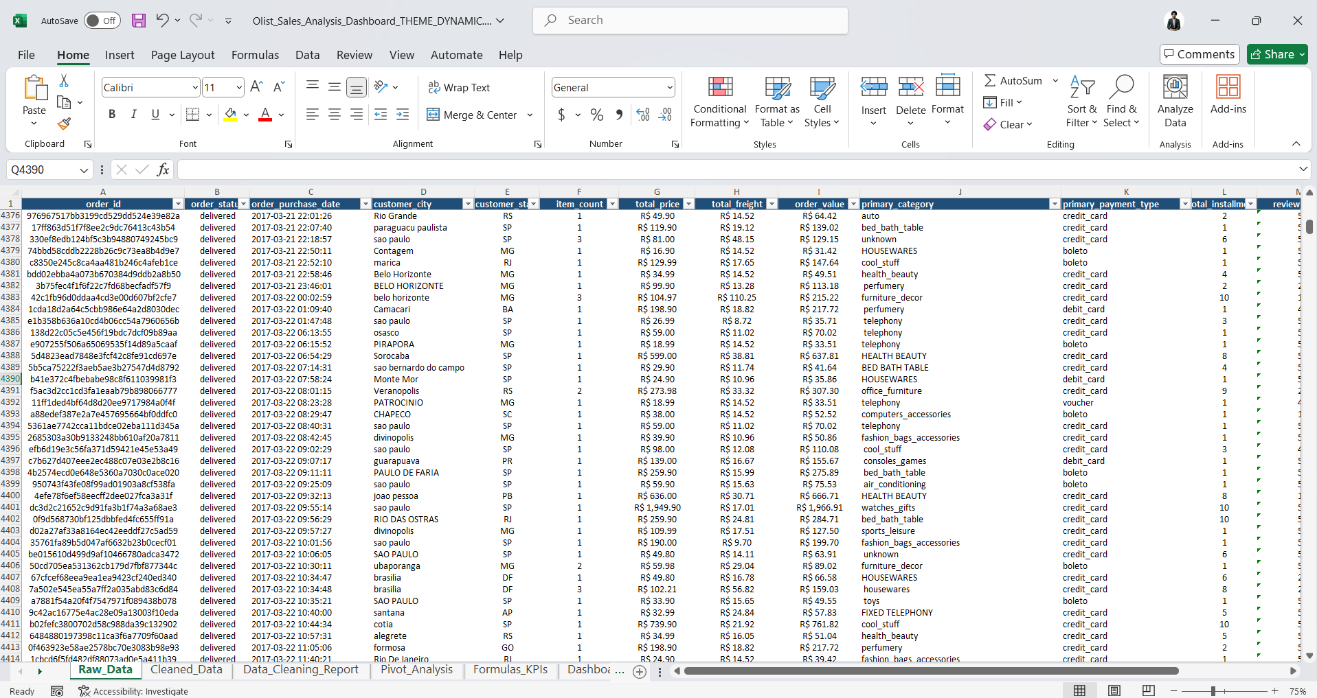
📸 Raw Data — showing messiness
3.2 After Cleaning (Cleaned Data)
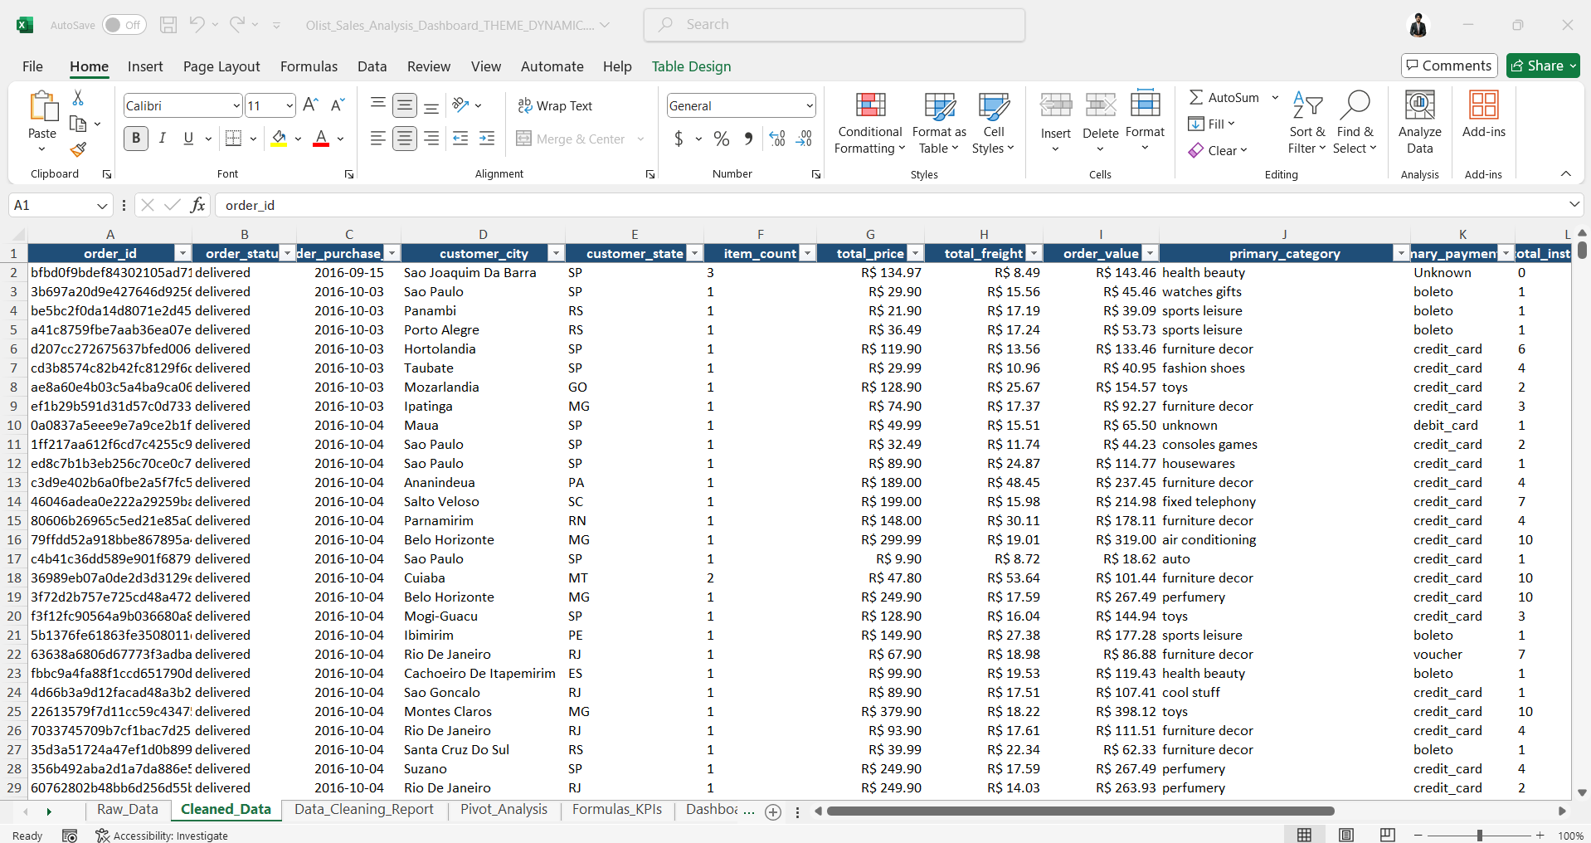
📸 Cleaned Data — after cleaning formulas applied
Issue | Formula Applied
City trailing spaces | =TRIM(PROPER(Raw_Data!D2))
Category casing | =LOWER(TRIM(SUBSTITUTE(...)))
State casing | =TRIM(UPPER(...))
Date as text | =IFERROR(DATEVALUE(LEFT(...)))
Missing reviews | Filled with 0
Missing delivery | Filled with median
Missing payment | Filled "Unknown"

3.3 Data Cleaning Report
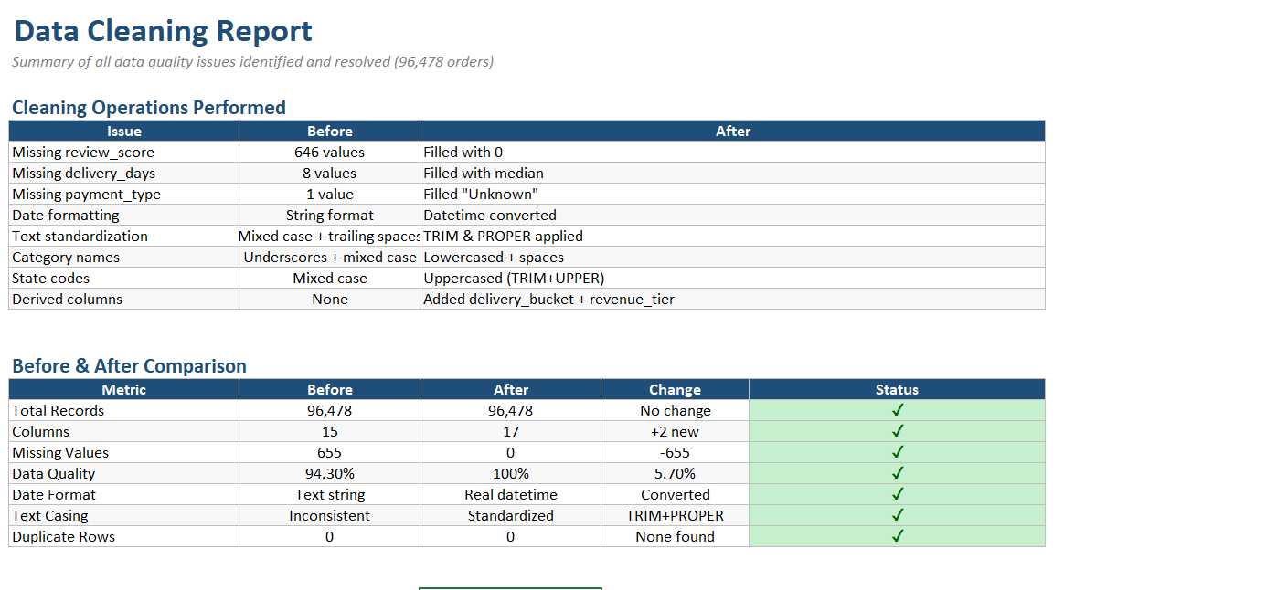
📸 Data_Cleaning_Report — Before/After comparison
3.4 Excel Overview (Video)

🎥 Video Overview — full Excel dashboard demonstration
▶️ Watch: https://drive.google.com/file/d/1-kpgPy8iV6V6QWU_i7hDavcFlzf9Xd2W/view?usp=drive_link
4. Data Aggregation — Pivot Tables
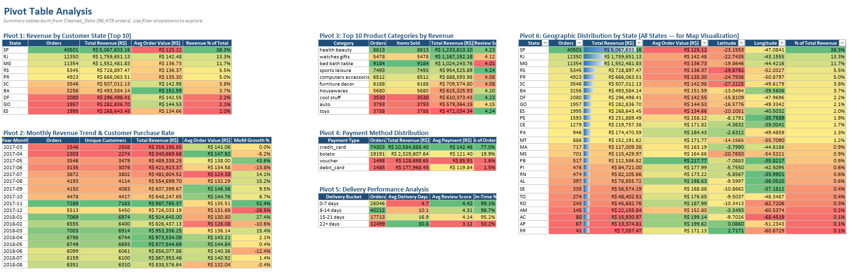
📸 Pivot_Analysis — all 6 pivot tables with conditional formatting

5. Formulas & KPI Scorecard
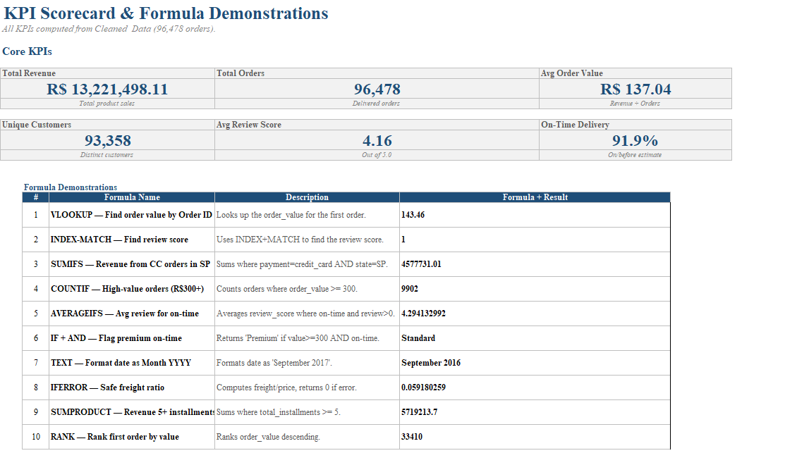
📸 Formulas_KPIs — 6 KPI cards + 10 formula demos
KPI | Formula | Value
Total Revenue | =SUM(CleanedDataTbl[total_price]) | R$ 13,221,498
Total Orders | =COUNTA(CleanedDataTbl[order_id]) | 96,478
Avg Order Value | =SUM(...)/COUNTA(...) | R$ 137.04
Avg Review | =AVERAGEIF(...) | 4.16 ★
On-Time vs Late | =TEXT(...)/TEXT(...) | 91.9% / 8.1%
Top State Revenue | =MAX(SUMIFS(...)) | R$ 282,837

6. Dashboard Development
6.1 Raw Dashboard
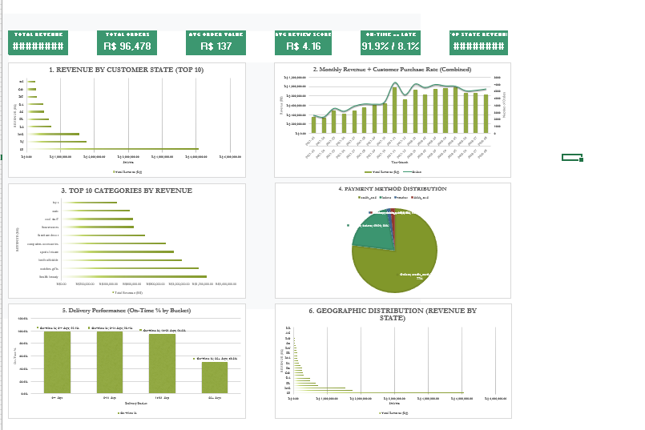
📸 Raw Dashboard — Looks messy & is not able to provide insights
6.2 Properly Formatted Dashboard
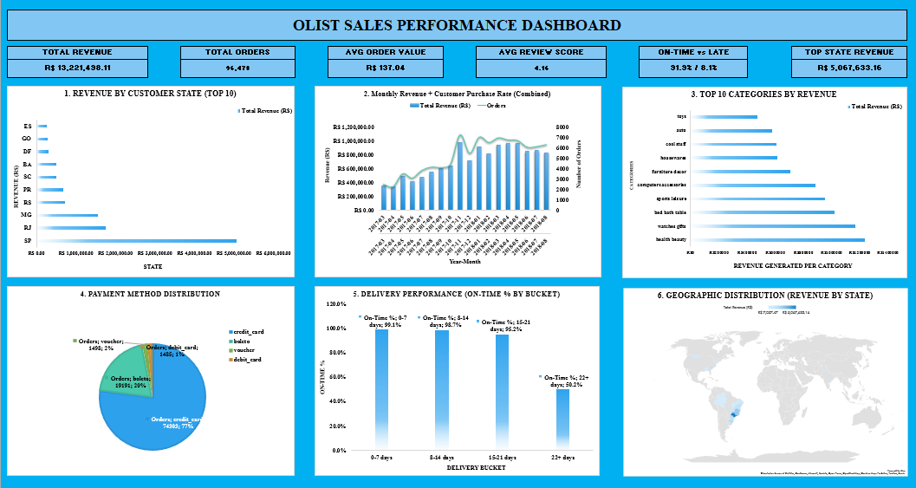
📸 Properly Formatted Dashboard — Able to provide proper insights

Chart | Type | Why
Revenue by State | Bar | Long labels
Monthly Revenue + Purchase Rate | Combo | Dual axes
Top Categories | Bar | Ranking
Payment Method | Pie | Composition
Delivery Performance | Column | Buckets
Geographic Distribution | Bar | All 27 states

7. Key Findings
1. Geographic concentration: SP = 38.28% of revenue
2. Pareto: Top 25% categories of products = 79.3% revenue
3. Payment: Credit card = 78.3%
4. Delivery: On-time 4.30★ vs late 3.12★
5. On-time rate: 91.89%, 7,826 late
6. Repeat rate: 3.12% — one-time-purchase driven
8. Excel Methods Used
Technique | Where Used
TRIM, PROPER, UPPER, LOWER | Cleaned_Data
SUBSTITUTE | Cleaned_Data
DATEVALUE + LEFT | Cleaned_Data
IFERROR | Everywhere
VLOOKUP, INDEX-MATCH | Formulas_KPIs
SUMIFS, COUNTIFS, AVERAGEIFS | Pivot_Analysis
SUMPRODUCT | Formulas_KPIs
TEXT, RANK | Formulas_KPIs
Color Scales + Data Bars | Pivot_Analysis
Theme Colors | Dashboard
Charts (Bar, Line, Combo, Pie) | Dashboard

9. Deliverables
File | Description
Olist_Sales_Analysis_Dashboard.xlsx | Complete workbook (6 sheets)
Task_2_Report.docx | This report

